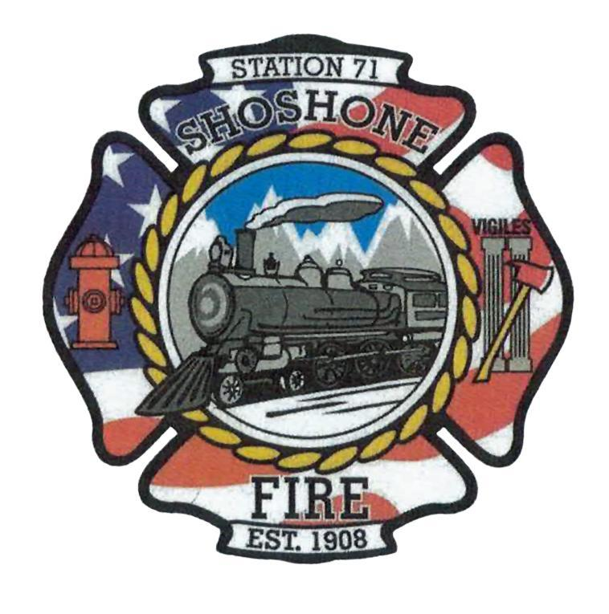
Shoshone City and Rural Fire Protection District
PO Box 461 Shoshone, ID 83352 (208)886-7500

2023 Meeting Schedule
The 2023 Regular Board Meetings are scheduled as follows:

January 9, 2023 Station 1 6 PM
February 13, 2023 Station 1 6 PM
March 13, 2023 Station 2 6 PM
April 10, 2023 Station 1 6 PM
May 8, 2023 Station 1 6 PM
June 12, 2023 Station 2 6 PM
July 10, 2023 Station 1 6 PM
August 14, 2023 Station 1 6 PM
September 11, 2023 Station 2 6 PM
October 9, 2023 Station 1 6 PM
November 13, 2023 Station 1 6 PM
December 11, 2023 Station 2 6 PM

To be added to the agenda, please contact Casey Kelley at (208)570-3599 or Angela Hubert at (208)739-8565 at least 5 days prior to the meeting date.

