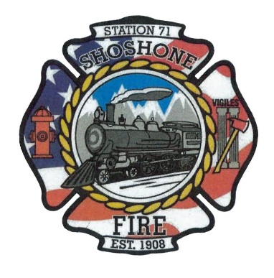
April 10, 2023
The regular meeting of the Shoshone City & Rural Fire District was called to order at 6:07 P.M.
The following members of the SCRFPD Board were present: Commissioner Owens and Commissioner Kelley
Others present: Angela Hubert, Kendall Rast, Nick Westendorf, Karla Davis, Ashley Diviak, and Sheriff King.
Executive Session entered at 6:07pm (Personnel selection and evaluation - Idaho Code 74-206(1)(a) and (b))
Executive Session ended at 6:37pm.
Citizens Correspondence, Issues, and Reports (speakers shall be limited to 3 minutes of discussion) – No Citizen Correspondence
Action Item –
Minutes – The March 2023 minutes were presented to the board for review.
Action Item – A motion was made by Commissioner Kelley to approve the minutes. The motion was seconded by Commissioner Owens. All in favor, motion carried.
Claims/Payroll – The claims and payroll were presented to the board for review.
Action Item – Commissioner Kelley made a motion to pay Wells Fargo Credit Card bill. The motion was seconded by Commissioner Owens. A motion was made by Commissioner Kelley to accept the claims and payroll. The motion was seconded by Commissioner Owens. All in favor, motion carried.
Commission Media Relations Update – Kendall is continuing to make progress on the department’s website. Commissioner Owens stated that the website will be a great tool in raising awareness in the community of what the fire department does.
Action Item –
Health Insurance Update – No update on health insurance
Action Item –
Fire District Lines – No update on progress with the fire district lines. The board is interested in continuing to push this issue with the County Commissioners.
Action Item –
Operational Updates – Presented by Kendall Rast. There were 12 calls this month that the fire department responded to. The pump is now fixed on Truck 71101 and a new valve has been installed. Truck 71101 still needs a pump seal replacement, but it is in service. The new fan was also installed on Truck 71101 and the old one was transferred to 71301. Progress is being made at Wild West Business Park. The businesses still need their final inspections. The department will have to start moving trucks from Station 2 to Station 1 to prepare for wildfire season. Kendall said that the department needs to find someone to spray weeds around Station 2. Commissioner Owens stated that he would address this issue. The Magic Valley H.O.T. Academy deadline is coming up. The chief would like to see a couple of firefighters attend this. Kendall will get the number of firefighters attending to Commissioner Owens, so we can get it all taken care of before the May 1st deadline.
Action Item –
Other Business – Chief Kelley will be taking a personal leave of absence for 30 to 40 days. The board is working on getting someone to fill in during this period.
Action Item –
The board members entered Executive Session at 6:59pm and exited at 7:06 pm.
Executive Session as needed per Idaho Code 74-206
• Personnel selection and evaluation - Idaho Code 74-206(1)(a) and (b)
• Acquire interest in real property - Idaho Code 74-206(1)(c)
• Consider records exempt from disclosure - Idaho Code 74-206(1)(d)
• Discuss litigation – with your attorney - Idaho Code 74-206(1)(f)
• Consider claims or potential claims – with your risk manager or insurer - Idaho
Code 74-206(1)(i)
Adjourn: 7:06 pm

