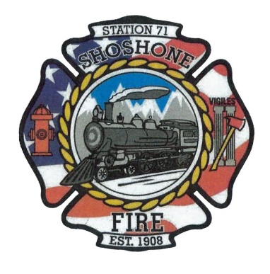
April 17, 2023
A special meeting will take place on Wednesday, April 19, 2023, at Shoshone Fire Department Station 1, located at 110 West A Street Shoshone, Idaho at 5:30 P.M.

Executive Session as needed per Idaho Code 74-206
• Personnel selection and evaluation - Idaho Code 74-206(1)(a) and (b)

To be added to the agenda, please contact Tony Owens at (208)308-3968, Casey Kelley at (208)570-3599, or Angela Hubert at (208)739-8565 at least 5 days prior to the meeting date.

