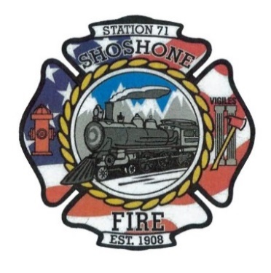
August 10, 2023
Budget Hearing
A Budget Hearing will be held August 14, 2023, at 6:00 P.M. This meeting will be held at Station 1, 110 West A Street, Shoshone, Idaho.
Regular Meeting
A regular meeting will take place on Monday, August 14, 2023, at Shoshone Fire Department Station 1, located at 110 West A Street Shoshone, Idaho following the Budget Hearing.
Citizens Correspondence, Issues, and Reports (speakers shall be limited to 3 minutes of discussion)-Action Item
Minutes-Action Item
Claims/Payroll-Action Item
Commission Media Relations Update-Action Item
Health Insurance Update-Action Item
Fire District Lines – Action Item
2023 Audit Engagement – Action Item
Selection of Full-Time Firefighter Position – Action Item
Operational Updates-Action Item
Other Business- Action Item
Executive Session as needed per Idaho Code 74-206
• Personnel selection and evaluation - Idaho Code 74-206(1)(a) and (b)
• Acquire interest in real property - Idaho Code 74-206(1)(c)
• Consider records exempt from disclosure - Idaho Code 74-206(1)(d)
• Discuss litigation – with your attorney - Idaho Code 74-206(1)(f)
• Consider claims or potential claims – with your risk manager or insurer - Idaho
Code 74-206(1)(i)
To be added to the agenda, please contact Tony Owens at (208)420-7430, Casey Kelley at (208)570-3599, or Angela Hubert at (208)739-8565 at least 5 days prior to the meeting date.

