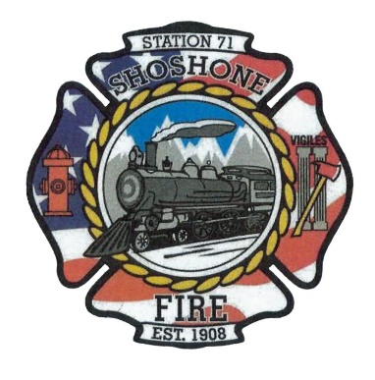
February 13, 2023
The regular meeting of the Shoshone City & Rural Fire District was called to order at 6:01 P.M.
The following members of the SCRFPD Board were present: Commissioner Kelley and Commissioner Race
Others present: Chief Casey Kelley, Angela Hubert, and Kendall Rast
Citizens Correspondence, Issues, and Reports (speakers shall be limited to 3 minutes of discussion) – No Citizen Correspondence
Action Item –
Minutes – The January 2023 minutes were presented to the board for review.
Action Item – A motion was made by Commissioner Race to approve the minutes as presented. The motion was seconded by Commissioner Kelley. All in favor, motion carried.
Claims/Payroll – The claims and payroll were presented to the board for review.
Action Item – A motion was made by Commissioner Race to accept the claims and payroll. The motion was seconded by Commissioner Kelley. All in favor, motion carried.
Commission Media Relations Update – Kendall is continuing to make progress on the department’s website.
Action Item –
Health Insurance Update – Commissioner Race learned that the department would be able to provide a policy for one person. A group policy is not necessary. Because open enrollment has ended, the policies available are limited and do not meet the needs of the chief. The department will have to wait until the next open enrollment to provide an insurance policy. Commissioner Kelley recommended that the department provide some funds to help supplement insurance costs. The board agreed to discuss this matter next meeting.
Action Item –
Fire District Lines – The issue with the fire district lines has been brought to the attention of the County Commissioners. The Shoshone Fire Department and surrounding fire departments are all on board to make a resolution. Currently, the departments are waiting on the County Commissioners to move forward. Chief Kelley agreed to touch base with the County Commissioners to determine what the next step will be.
Action Item –
COVID-19 Policy Update – The current policy within the department is business as usual. The board discussed the current COVID in the area. The board agreed to keep the current policy.
Action Item –
Operational Updates – Given by Chief Casey Kelley. There were 5 service calls this month. A second inspection was completed at Blue Fire. Blue Fire passed their inspection. An inspection was also completed at the Head Start. Head Start also passed their inspection. The fire department has four people attending the Fire Academy this upcoming weekend. The air leak on Truck 71701 is being addressed. New batteries were purchased for Truck 71102. The fan off Truck 71102 was taken to T&L. Chief Kelley stated that an Awards Banquet used to be held each year for the firefighters, prior to COVID. He asked if we could bring back the banquet for the firefighters. The board agreed that the Awards Banquet would be a good idea.
Action Item –
Other Business –
Action Item –
Executive Session as needed per Idaho Code 74-206
• Personnel selection and evaluation - Idaho Code 74-206(1)(a) and (b)
• Acquire interest in real property - Idaho Code 74-206(1)(c)
• Consider records exempt from disclosure - Idaho Code 74-206(1)(d)
• Discuss litigation – with your attorney - Idaho Code 74-206(1)(f)
• Consider claims or potential claims – with your risk manager or insurer - Idaho
Code 74-206(1)(i)
Adjourn: 6:51 pm

