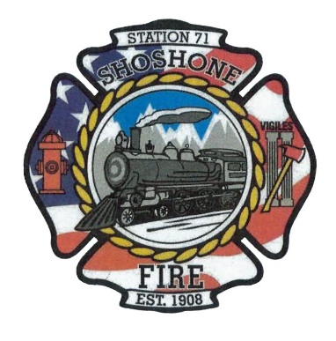
July 17, 2023
A special meeting of the Shoshone City & Rural Fire District was called to order at 5:32 P.M.
The following members of the SCRFPD Board were present: Commissioner Owens, Commissioner Kelley, and Commissioner Race.
A discussion was held on how to obtain applications for the position. Commissioner Owens will be the point of contact for the applicants.
A discussion was held on how long the position will be available to firefighters in house. After some discussion, it was decided that it will be available in house for two weeks. Applications will be due by July 31st at 5:00 P.M.
A meeting will be held on July 31st at 5:30 P.M. to open and discuss applications.
Commissioner Race will fine tune the job description. Commissioner Owens stated that he will send out a group text to inform members of the department of the opening. The job description will be posted at Station 1 and 2.
Commissioner Race made a motion to move forward with advertising in house for a full-time fire fighter position. Commissioner Kelley seconded the motion. All in favor, motion carried.
An amendment to the motion was made to open up the position in house on July 17th.
The meeting was adjourned at 5:52 P.M.

