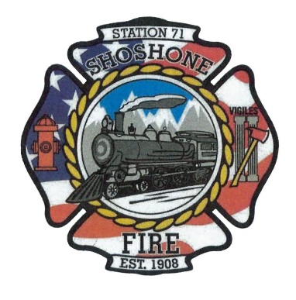
July 24, 2023
A special meeting of the Shoshone City & Rural Fire District was called to order at 5:34 P.M.
The following members of the SCRFPD Board were present: Commissioner Owens, Commissioner Kelley, and Commissioner Race.
Others: Chief Kelley, Angela Hubert, Kendall Race and Karla Davis
Commissioner Race presented the current budget schedule for the department.
The board members reviewed previous years L2’s and the predicted L2 for next year.
The board members reviewed our expected revenue for 2024’s budget.
The board members reviewed our expected expenditures for 2024. Commissioner Race recommended expanding our expenditure categories. This will help the department have a more accurate budget. Commissioner Race also recommended that the department codes our expenditures. Coding expenditures will help us to better track our expenditures. The added position to our department brings a deficit to our projected budget. A discussion was held on where we could find the money in our budget to eliminate the deficit.
The board decided that another meeting was necessary to finish the discussion on the budget.
A meeting will be held on Friday July 28th at 5:00 P.M.
The meeting was adjourned at 6:58 P.M.

