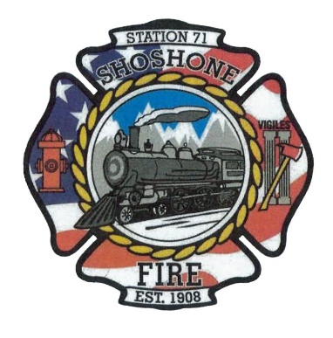
July 28, 2023
A special meeting of the Shoshone City & Rural Fire District was called to order at 5:34 P.M.
The following members of the SCRFPD Board were present: Commissioner Owens, Commissioner Kelley, and Commissioner Race.
Others: Chief Kelley, Angela Hubert, Kendall Race and Karla Davis
2024 Budget - Ideas were discussed on how the department could reduce expenditures for the 2024 Budget. In order to fit the wages for a full-time firefighter position into our 2024 Budget, the department will have to look into cutting back some expenditures. Commissioner Owens stated that we may be able to reduce our spending on the audit. The board members were in agreement to look into less expensive options for the upcoming audit. Commissioner Owens stated that he could get a quote from one auditor he knows. Another idea that was discussed was to contact Disaster Services and check into available grants to cover the costs of turnout gear and other equipment. The board members discussed the current lawn service that the department pays for. With the added full-time position, the board was in agreement that one of the department’s employees can accomplish care of the lawn. The board members were originally hoping to cover 50% of the cost of health insurance for their full-time employees. The members of the board were in agreement that for this year 30% of the health insurance cost would fit into the budget. Commissioner Kelley presented the idea of not using an accountant and having the secretary complete this role. The board members were in agreement that this could be a possibility, but more discussion with the current secretary is needed.
Commissioner Race made a motion to enter executive session at 6:20 P.M. Commissioner Kelley seconded the motion. All in favor, motion carried.
Executive Session as needed per Idaho Code 74-206
• Personnel selection and evaluation - Idaho Code 74-206(1)(a) and (b)
• Acquire interest in real property - Idaho Code 74-206(1)(c)
• Consider records exempt from disclosure - Idaho Code 74-206(1)(d)
• Discuss litigation – with your attorney - Idaho Code 74-206(1)(f)
• Consider claims or potential claims – with your risk manager or insurer - Idaho
Code 74-206(1)(i)
A motion was made at 6:35 P.M. to exit executive session.
4 Gas Meter – Kendall presented a quote for a Gas Meter to the board. This is the model that he feels would best meet the needs of the department. The board members discussed putting a second gas meter on the department’s 5-year plan.
Action Item – Commissioner Race made a motion to approve the purchase of the Gas Meter. Commissioner Kelley seconded the motion. All in favor, motion carried.
Through the discussion that was held, the board members were able to reach an agreement on a projected budget for 2024. Commissioner Race stated that she will work with getting the Notice of Public Hearing. Commissioner Owens stated that he will contact Payson with Disaster Services and determine what funds would be available for the department.

Adjourn: 6:53 P.M.

