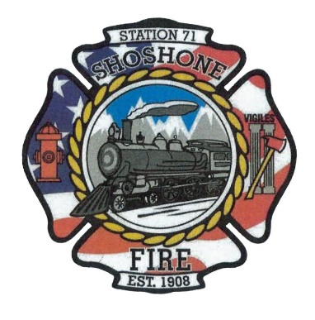
July 26, 2023
A special meeting will take place on Friday, July 28, 2023, at Shoshone Fire Department Station 1, located at 110 West A Street Shoshone, Idaho at 5:00 P.M.

Items of Business:
2024 Budget – Action Item
Gas Meter – Action Item

