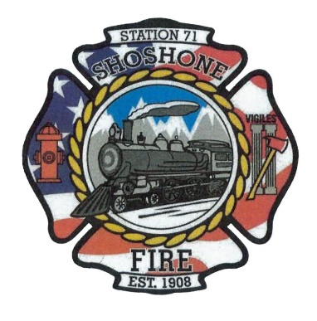
June 12, 2023
The regular meeting of the Shoshone City & Rural Fire District was called to order at 6:05 P.M.
The following members of the SCRFPD Board were present: Commissioner Owens, Commissioner Kelley, and Commissioner Race.
Others present: Angela Hubert, Kendall Rast, and Nick Westendorf
Citizens Correspondence, Issues, and Reports (speakers shall be limited to 3 minutes of discussion) – No Citizen Correspondence
Action Item –
Minutes – The May 2023 Minutes were presented to the board for review.
Action Item – A motion was made by Commissioner Kelley to approve the minutes. The motion was seconded by Commissioner Race. All in favor, motion carried.
Claims/Payroll – The claims and payroll were presented to the board for review.
Action Item –A motion was made by Commissioner Race to accept the claims and payroll. The motion was seconded by Commissioner Kelley. All in favor, motion carried.
Commission Media Relations Update – No update on the website.
Action Item –
Health Insurance Update – No update on health insurance.
Action Item –
Fire District Lines – No update on progress with the fire district lines. The board is interested in continuing to push this issue with the County Commissioners.
Action Item –
Review Hourly Rates for Volunteer Firefighters – Commissioner Race contacted multiple neighboring departments to compare hourly rates. She determined that we were comparable in our hourly rates. The board decided to address this again during budget season.
Action Item –
Richfield Fire District Pre-Plans – Richfield Fire Department is currently without a chief. They contacted us and asked if our department would be able to help complete their inspections until they can hire a chief. Commissioner Owens asked attending volunteers who is qualified to complete inspections. The chief usually completes the inspections in our department. Commissioner Owens was also interested in the liability associated with completing inspections for another department. This was not known by the attending firefighters.
Action Item – Commissioner Kelley made a motion that the Shoshone Fire Department cannot currently help Richfield with their inspections. This motion was seconded by Commissioner Race. All in favor, motion carried.
Shoshone School District 40 Hour Community Internship – Shoshone School currently has a student interested in becoming a firefighter. This student is interested in completing their unpaid community internship at the fire department. It was decided by the board that this student could attend drills to complete their required 40 hours.
Action Item –
Operational Updates- There were 6 calls during the month of May. The Rush bill that was approved by the board this month was due to truck 71701 needing a new air dryer and relief valve. New batteries were also purchased for 71701. The fire department is planning to help with the 4th of July BBQ and Fireworks again this year. Commissioner Owens asked Kendall to reach out to volunteers in hopes of getting some of them to commit to helping. The firefighters have also been asked to contribute at Arts in the Park July 8th and 9th. The firefighters will have the SCPHD training on July 21st. The fire department has also been tasked with helping to complete the placement of reflective address signs.
Action Item –
Other Business – Commissioner Race asked the attending firefighters about the training given by Jacki Briggs from Courageous Survival. The firefighters stated that the training was very beneficial. It was well attended by our firefighters. We also had attendees from neighboring departments. The firefighters felt that future trainings would benefit the department.
Action Item –
Commissioner Owens moved and Commissioner Race seconded the motion to enter Executive Session at 6:33 pm and a motion was made at 7:40 pm to exit Executive Session.
Executive Session as needed per Idaho Code 74-206
• Personnel selection and evaluation - Idaho Code 74-206(1)(a) and (b)
• Acquire interest in real property - Idaho Code 74-206(1)(c)
• Consider records exempt from disclosure - Idaho Code 74-206(1)(d)
• Discuss litigation – with your attorney - Idaho Code 74-206(1)(f)
• Consider claims or potential claims – with your risk manager or insurer - Idaho
Code 74-206(1)(i)
Adjourn: 7:43 pm

