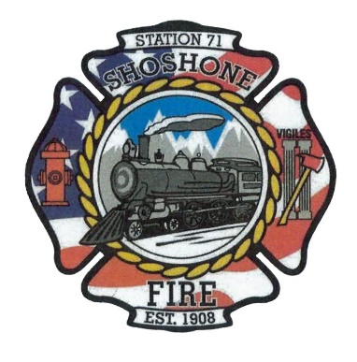
March 13, 2023
The regular meeting of the Shoshone City & Rural Fire District was called to order at 6:05 P.M.
The following members of the SCRFPD Board were present: Commissioner Owens and Commissioner Race
Others present: Chief Casey Kelley, Angela Hubert, and Kendall Rast
Citizens Correspondence, Issues, and Reports (speakers shall be limited to 3 minutes of discussion) – No Citizen Correspondence
Action Item –
Minutes – The February 2023 minutes were presented to the board for review.
Action Item – A motion was made by Commissioner Race to approve the minutes with a clarification on the health insurance portion of the minutes. The motion was seconded by Commissioner Owens. All in favor, motion carried.
Claims/Payroll – The claims and payroll were presented to the board for review.
Action Item – A motion was made by Commissioner Race to accept the claims and payroll. The motion was seconded by Commissioner Owens. All in favor, motion carried.
Commission Media Relations Update – Kendall is continuing to make progress on the department’s website. Angela needs to forward agendas and minutes to Kendall each month.
Action Item –
Health Insurance Update – It was determined last meeting that there is currently not a health insurance plan available that meets the needs of the Chief. Commissioner Owens asked if a Health Savings Plan or Account is a possibility. Commissioner Race stated that a Health Savings Account is not an option for the department. The commissioners decided that they want health insurance on the agenda during the budget season, so the board can ensure that they include it in the budget. The board also determined that health insurance should be included in the October agenda, so we can be prepared for open enrollment.
Action Item –
Fire District Lines – Chief Kelley stated that Nathan Schutte, County Commissioner, is putting together a map of the county to better determine what is in and out of each district. This will be helpful to determine who should be in each fire district. The County Commissioners are figuring out the legalities of everything with the prosecutors. Currently, all the departments are waiting on the County Commissioners to move forward.
Action Item –
COVID-19 Policy Update – The current policy within the department is business as usual. The board discussed the current COVID in the area. The board agreed to keep the current policy. The board also determined that it is no longer necessary to keep COVID on the agenda each month. If it becomes a problem in the future, it can be added back to the agendas.
Action Item –
Operational Updates – Given by Chief Kelley. There were 12 service calls this month. Joe Robinette retired from Jerome Rural Fire Department and Chief Kelley attended the celebration in his honor. The department has been having pump issues with 71101. The truck still has a lot of life in it, so this issue needs to be addressed. Truck 71101 also requires a battery tender. The air compressor at Station 2 needed a couple repairs this month. The structure fire that was responded to went well. Shoshone, Dietrich, Richfield, and Gooding departments all responded to the fire. There is finally a date in June to move forward with the Zortman’s Supreme Court Case. Chief Kelley also asked the board if he would be able to purchase a tablet. The chief stated that this would help them to be better prepared to respond to calls. The tablet would allow them to see more details for each call.
Action Item –
Other Business –
Action Item –
Executive Session as needed per Idaho Code 74-206
• Personnel selection and evaluation - Idaho Code 74-206(1)(a) and (b)
• Acquire interest in real property - Idaho Code 74-206(1)(c)
• Consider records exempt from disclosure - Idaho Code 74-206(1)(d)
• Discuss litigation – with your attorney - Idaho Code 74-206(1)(f)
• Consider claims or potential claims – with your risk manager or insurer - Idaho
Code 74-206(1)(i)
Adjourn: 7:20 pm

